Introduction

- I want to get an alpha particle detector working using a CircuitPython microcontoller.
- Source: A smoke detector source, Am-241, half life 432 years, primary decay product is a alpha particle with energy 5.486 MeV.
- Detector: An S1223 photodiode with the glass window removed. The alpha’s directly hit the photodiode and their energy is converted into electron-hole pairs which give a small burst of current.
- Circuit. An MCP6022 op amp. The 6022 runs off of 3.3V power and has rail-to-rail input and output.
- An AdaFruit Feather ESP32S2 TFT microcontoller.

Circuit
I wired and debugged the circuit in Figure 1.
A picture of the circuit on a breadboard is in Figure 2.
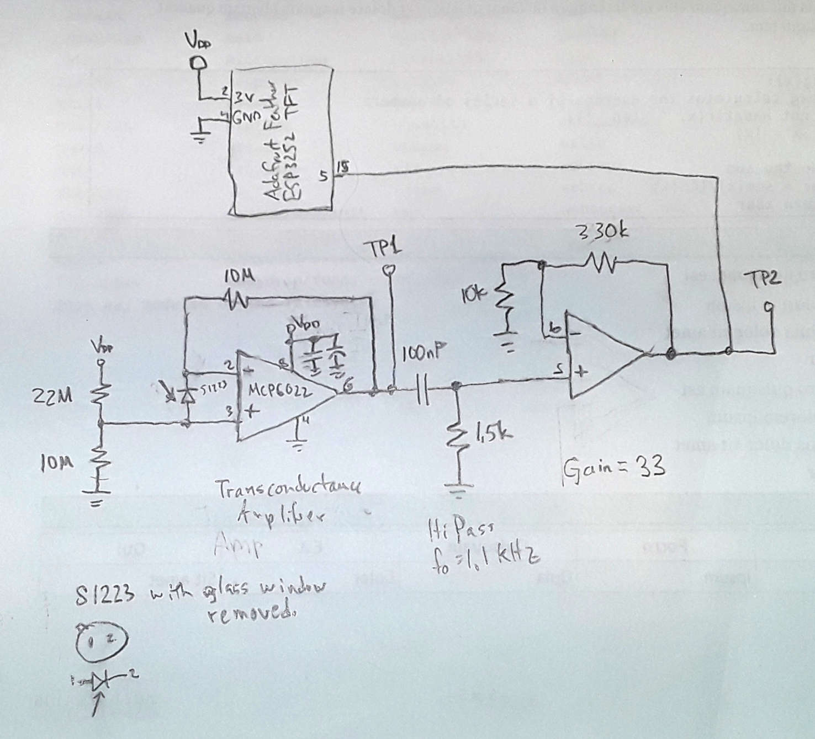Figure 1: Schematic of alpha particle detector. The bypass capacitors are a 0.1 uF ceramic and a 1.0 uF tantalum. NOTE: there are changes to this circuit documented below.
You can see in Figure 2 how I kept the wires as short as possible and the whole circuit very compact.
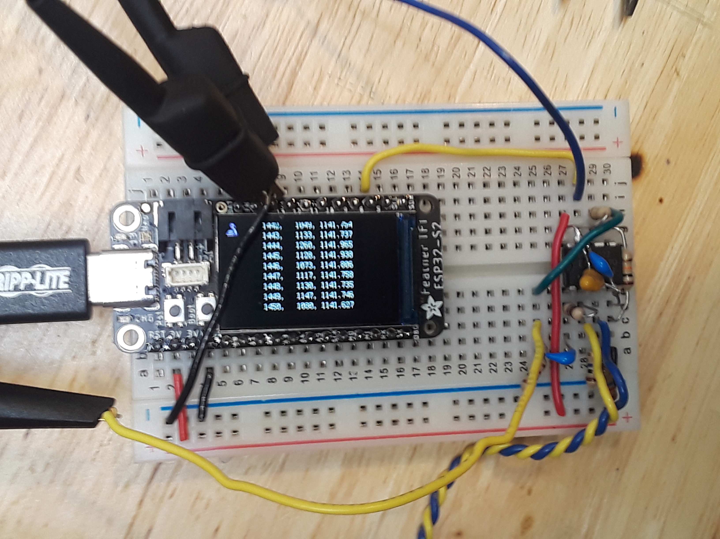Figure 2: A picture of the circuit on a breadboard. The blue and yellow twisted pair of wires go to the S1223 photodiode. The display shows the time, counts per second, and the average of the counts per second.

Circuit Design
The positive input of the first op amp is biased to about 1 V. The reason for this is that the op amp is running on a single side so there are no negative voltages. Second I had 60 Hz noise in the signal. With the positive terminal at ground, some 60 Hz with clipped at zero was in the output of the op amp. By biasing the positive input, the output was offset to about 1 V. When an alpha particle hits a burst of current flows through the photodiode. This has two effects. First the positive input of the op amp get a voltage pulse of i_{α}/1x10⁷. Second, the photocurrent also flows through the feedback resistor giving a voltage pulse of the same size.
Figure 3: The pulse from the photodiode after the high pass filter. The height is about 100 mV, and the width is about 12 us.
The pulses from the alpha particles could be easily seen at test point 1 (TP1.) They have an amplitude of about 100 mV and a width 15 us, as shown in Figure 3. The op amp is followed by a high pass filter to get rid of 60 Hz noise. The second op amp buffers the high pass filter and gives a gain of 33. This is so that most of the alpha peaks saturate around 3.3 V and can trigger the counting on the microcontoller.

Data & 60 Hz Problems
Initially the data looked good. I took data with a source – detector distance about 2 mm.
Afterwards I noticed the histogram has a width larger than the Poisson distribution, so something may be off.
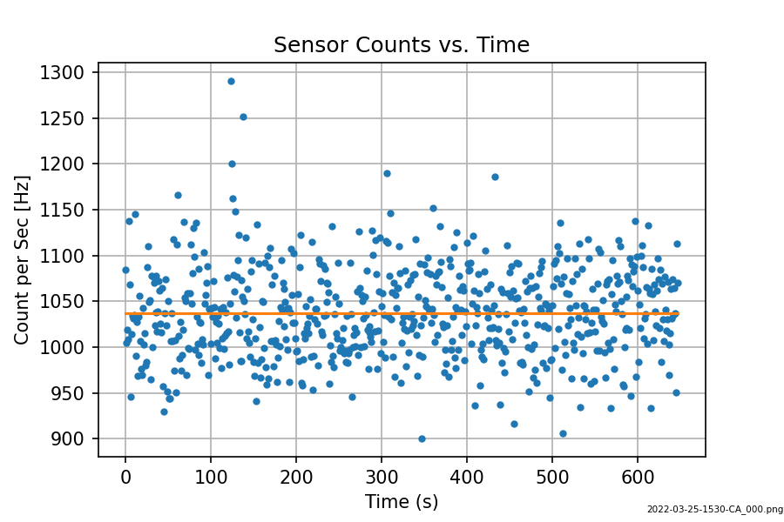Figure 4: Counts versus time. Source-detector distance about 1 mm.
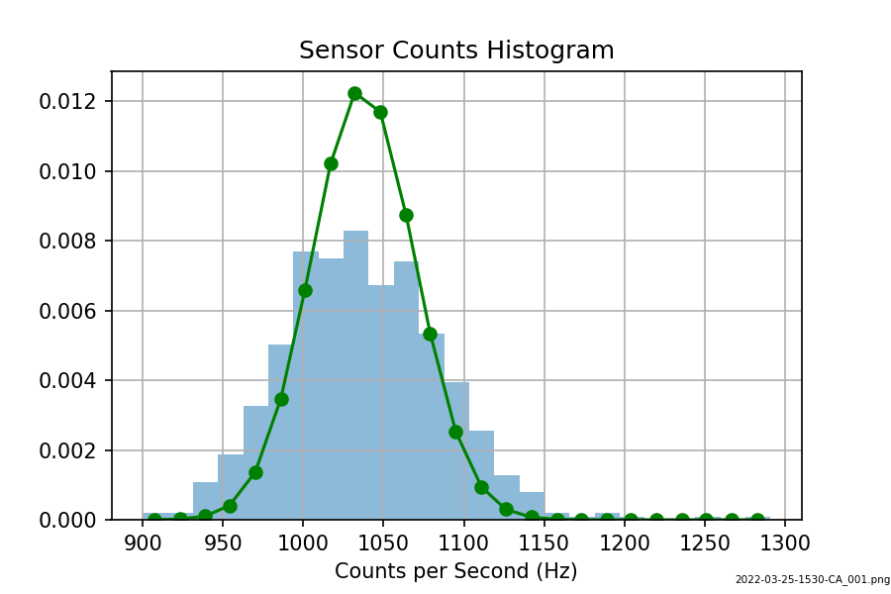Figure 5: Histogram. The curve is a Poisson distribution using the average counts as the parameter.
Next I moved the source away from the sensor. I started picking up noise at 60 Hz. And example of the data is in the figures below.
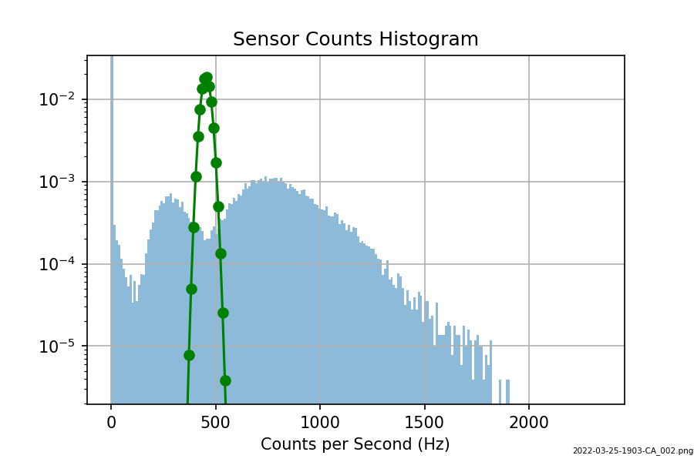Figure 6: There is clearly a lot of noise in the data.
There was a lot of sensitivity to 60 Hz noise. For example I would just move my hand near the circuit or the box with the sensor and source and it would pick up so much 60 Hz, the circuit was dominated by the 60 Hz.
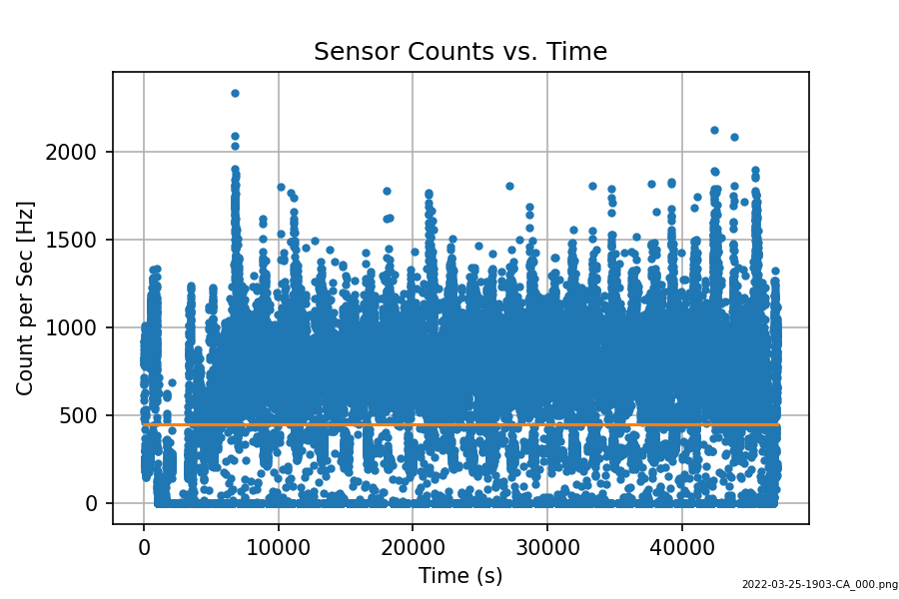Figure 7: Source - sensor distance 8 mm.
When I put the scope on the +In of the transimpedence amp, there was about 1 Vpp of 60 Hz. About the same at the In, but way less on the output. About 1 mV after the passive highpass filter.

2022-03-29 Tue.
I tied a couple of things.
- Mount the sensor right to the op amp on the breadboard and move the sensor close. This cut down the 60 Hz on -In and +In.
- Change the resistor on the passive high-pass to 10 k. This put the -3 dB frequency at 11 kHz.
- Added 10 uF electrolytic capacitor to the breadboard supply rails next to op amp.
- Change feedback resistor on op amp 2 to 66 k. This boosted the gain to about 66. The reason I changed the final gain was that I changed photodiodes and the signal pulses were smaller. This resulted in the final pulses into the microcontoller were not large enough to trigger the counting. It seems like the pulses have to cross ½ V_{DD}, about 1.7 V, to trigger the counting.
Now:
- There is about 50 mVpp 60 Hz on both +In and -In, about 30 mVpp on Out. After the passive high-pass filter the 60 Hz is gone!
- The data looks more Poisson-like.
Now the signal is very clean as seen in Figure 8. Figure 9 shows the pulse into the microcontoller is clean and easily triggers the counting.
Figure 8: Alpha particle pulse after passive high pass filter.
Figure 9: Alpha particle pulse. Blue is pulse going into the microcontroller.
Next I took data with the source about 5 mm from the detector.
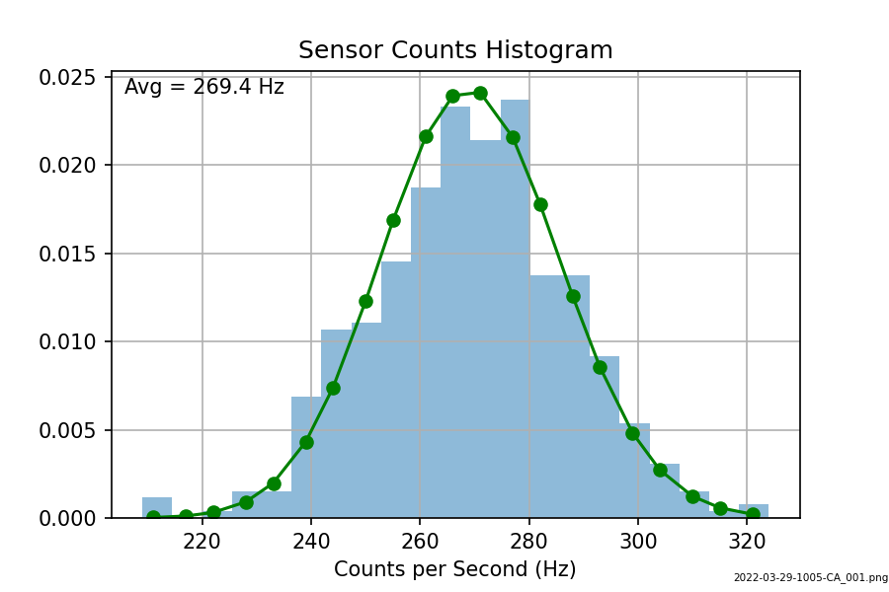Figure 10: Histogram. Source - sensor distance about 5 mm. The green curve is a Poisson distribution.
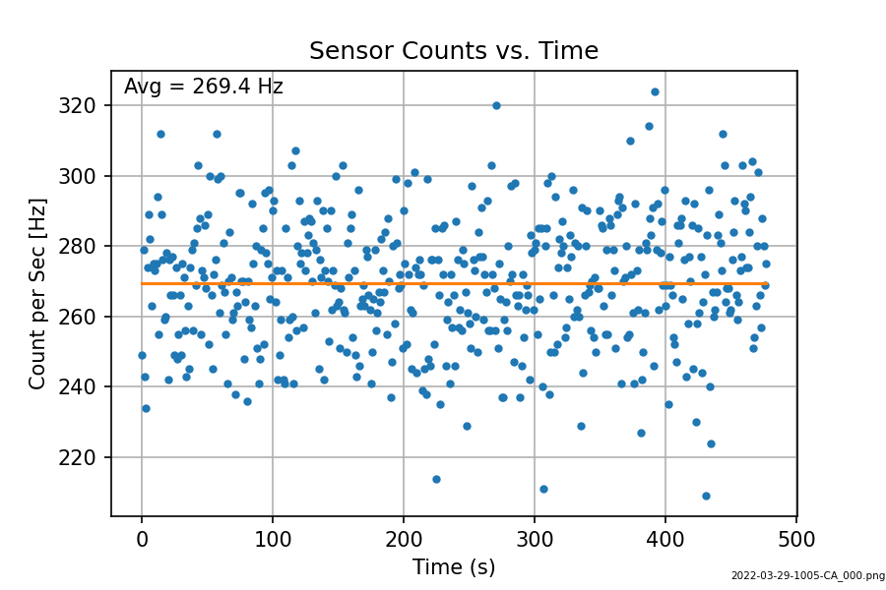Figure 11: Time series of data. There are no outliers.

Next I moved the source farther from the detector.
.
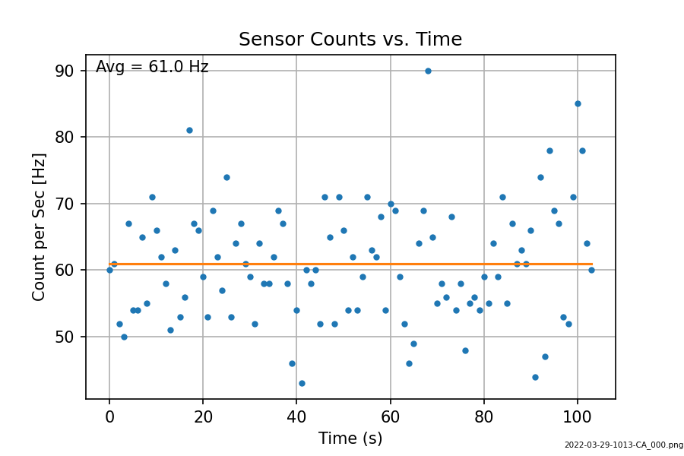Figure 12: Source farther from the sensor.
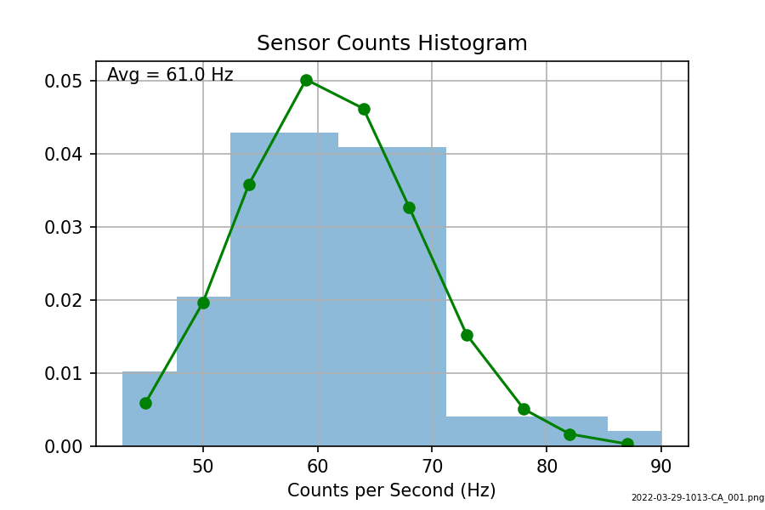Figure 13: The histogram looks like a Poisson distribution.

